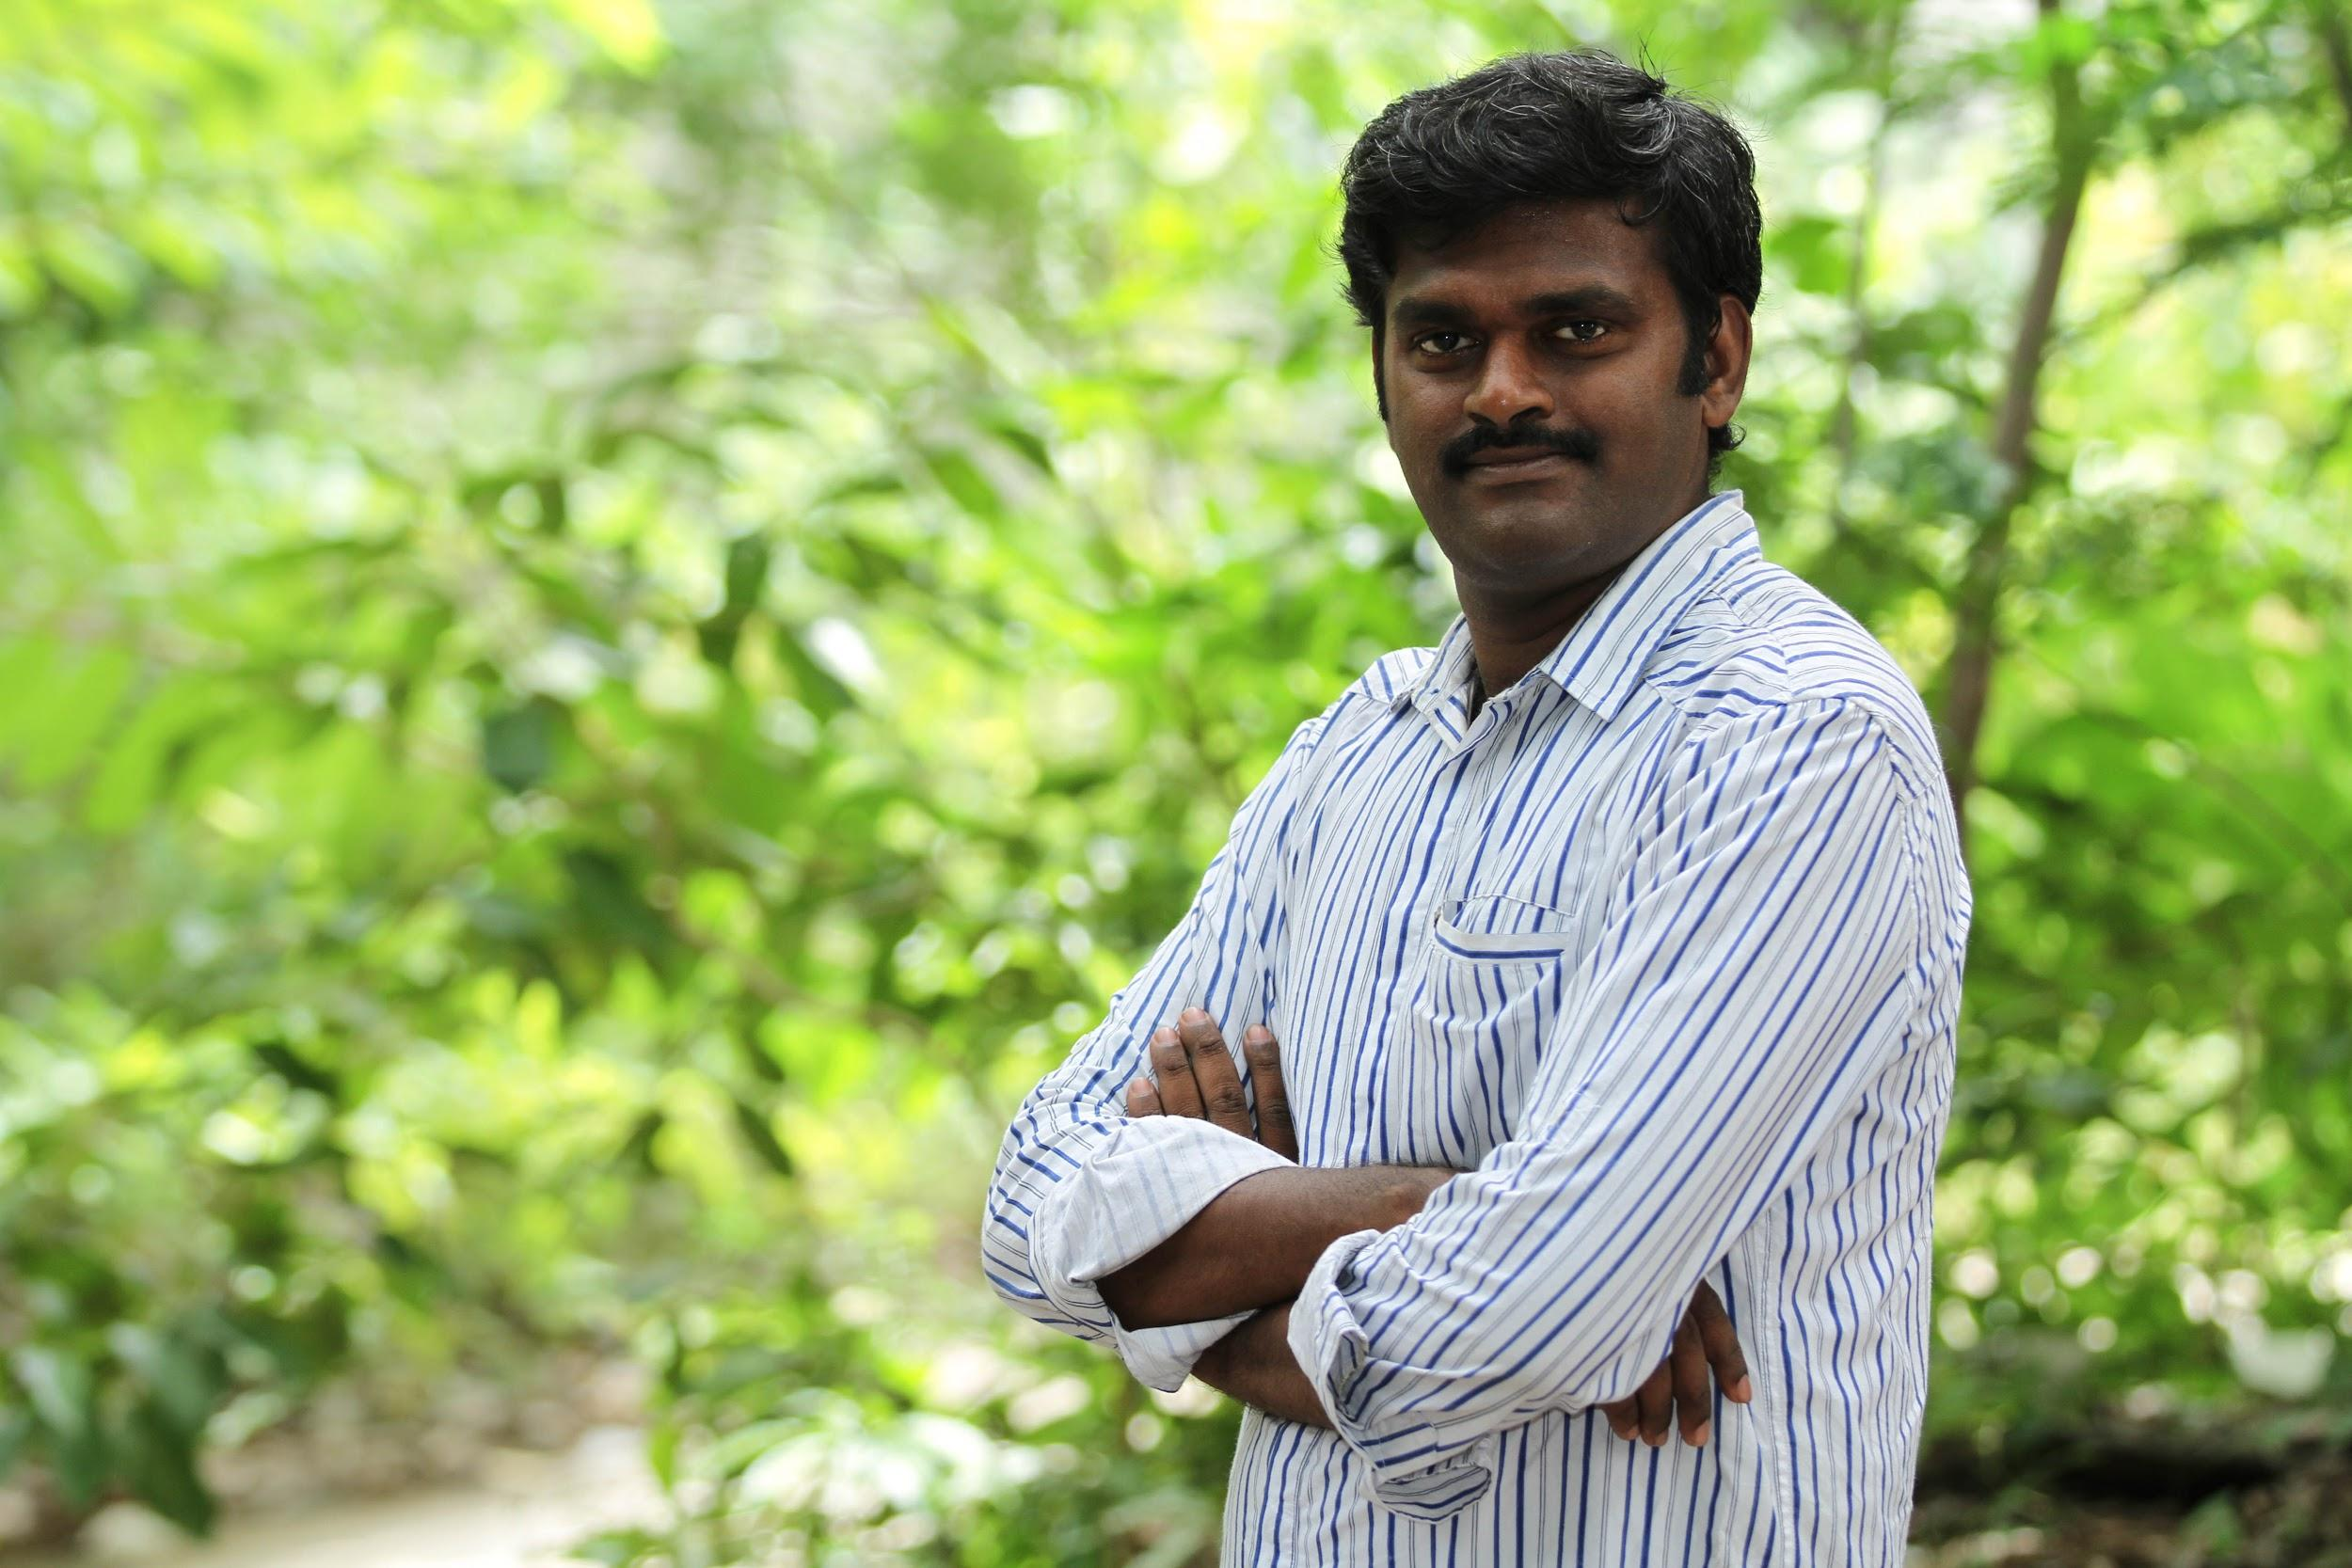
Nomination for T. Shrinivasan - தமிழ் கணிமைக்கான சுந்தர ராமசாமி விருது

T. Shrinivasan (த. சீனிவாசன்) is a passionate advocate and an exemplary contributor to Tamil computing related FOSS (Free and Open Source) software. He has been promoting Free Culture movements in Tamil for over ten years. He has developed tools related to OCR, which enabled transcribing thousands of Tamil books, adding more than 500,000 pages to Tamil Wikisource and Noolaham Digital Library. His tools also support the growth of other Indian languages. He is the former coordinator for the Indian Linux Users Group Chennai and the founder of non-profit community project FreeTamilEbooks, which publishes DRM-free ebooks in Tamil under Creative Commons licenses. Till date, it counts more than 3.9 million ebook downloads.

He started an online magazine run by volunteers for Free Software in Tamil, Kaniyam. Kaniyam has published several technical Tamil books such as “எளிய தமிழில் GNU/Linux”, “எளிய இனிய கணினி மொழி – ரூபி” and “எளிய தமிழில் MySQL”. He has written numerous technical articles in Tamil, covering emerging programming languages, tools, and technologies. He has trained and mentored numerous individuals such as Thagaval Uzhavan who in turn contribute back to community projects.

He is a technical contributor to Noolaham Foundation. His contribution includes helping to build the multimedia platform, extracting templated metadata from MediaWiki, and research into next-generation digital preservation infrastructure.

Shrinivasan serves as the coordinator for INFITT’s India Chapter. He is currently working as a Systems Architect in a private software services firm at Chennai. You can follow him on Twitter at @tshrinivasan or contact him at tshrinivasan@gmail.com.

About FreeTamilEbooks

Free Tamil Ebooks is a non-profit initiative providing hundreds of free ebooks to readers in the Tamil language. This is a unique project in the South Asian languages. Volunteers compile Creative Commons-licensed writings by popular bloggers and authors into ebook format. Started in 2013, they have released 280 ebooks till date counting 3.9 million downloads. Each book gets downloaded at least 500 times, but a few books have crossed the 1,00,000-download threshold. True to his FOSS ethos, Free Tamil Ebooks source code is freely availble at: https://github.com/kishorek/Free-Tamil-Ebooks Learn more from the Interview in Pressbooks
About OCR tool for Wikisource projects

OCR for Wikisource is a game-changing tool that converts Pdf or Djvu files to text using Google OCR and uploads the content automatically to Wikisource. Since December 2015, this tool is under active development with intense collaboration from various Indian language Wikimedia communities. By September 2016, the tool has added more than 900,000 pages to Bengali and Tamil Wikisource projects. Addition of 2000 nationalized books to Tamil Wikisource is a significant milestone. This also catapulted Tamil in to the list of Top 10 Wikisources in the word by page count. The same tool is used by Noolaham project to OCR Tamil works from Sri Lanka and make it searchable online.

Links

- Linkedin profile
- Blog
- GitHub tools
- Kaniyam magazine
- Free Tamil Ebooks

Profile photo by Jasan Pictures released under CC-BY-SA 4.0

